Software Specifications Document (SSD)
Entity Enhancement

Profile
Title | Conversion for Customer Master List
Tracking #
Product Line
Product Line |  |  |  | Style Master conversion
Module(s) | Inventory Control
Entity Type
Entity(s) | 1
Customer | Cam09 (Camp David )
Date Created | 06/17/2005
Author | Samah Mechael
Date Edited | 06/20/2005
Editor
Analysis | Approved By
Analysis | Approval Date |  | MM / DD / YYYY
Conceptual Design | Approved By
Conceptual Design | Approval Date |  | MM / DD / YYYY
Detailed Design | Approved By
Detailed Design | Approval Date |  | MM / DD / YYYY

Table of Contents
Profile 1
Table of Contents 2
Document Sections 3
Versions 3
Vision 4
Stakeholders 4
Needs 5
CFN – Customer Functional Needs 5
CTC – Customer Technical Needs 5
AFN – Aria Functional Needs 5
ATC – Aria Technical Needs 5
ATT – Aria Testing Needs 5
AMT – Aria Marketing Needs 5
ADT – Aria Documentation Needs 5
AST – Aria Supplementary Needs 5
Project Scope 5
1. In/Out Domains 5
2. Project Phases 5
Entity Features 6
User Interface (UI) 6
Option Grid 6
Use Cases 6
UI Rules 7
Option Grid Rules 7
Application Tier 8
Database Design 9
Testing Cases 9

Document Sections
Analysis
Vision
Stakeholders
Needs *
Customer Functional Needs
Customer Technical Needs
Aria Functional Needs
Aria Technical Needs
Aria Testing Needs
Aria Marketing Needs
Aria Documentation Needs
Supplementary Needs
Project Scope
Conceptual Design
Entity Features
User Interface (UI)
Option Grid
Use Cases
Detailed Design
UI Rules
Option Grid Rules
Application Tier
Database Design
Testing Cases
* At least one of the two functional needs sections must be filled.

Versions
Ver # | Date | Modified By | Sections Change Tracking
Ver # | Date | Modified By | New | Deleted | Changed
0.1 | 06/20/2005 | Samah Mechael

Vision
We need to convert the style master list sent to us from Camp David to Aria data taking into consideration the other database required for Aria Systems to function properly

Stakeholders
Role | Category | Description | Comments
Aria users in CampDavid | User

Needs

CFN – Customer Functional Needs
Camp David Inc need to convert the data for the style Master file from MAS90 to Aria Data for both the billing and shipping records

AFN – Aria Functional Needs
- While converting the data sent from CampDavid for the style Master list we will take into consideration all the extra files needed by Aria Systems .Ex:, warehouse file, codes, notes, …
- We will use the same codes for the style sent from Campdavid as is except for the styles that have a width bigger than 12 chars. , it will be sent in a separate list.
- Listed below are the files of Aria Systems that should be converted with the style master file:
  - Scale file: This will read the 4 scales from the Product line size scale file sent from Campdavid and attached below in this document
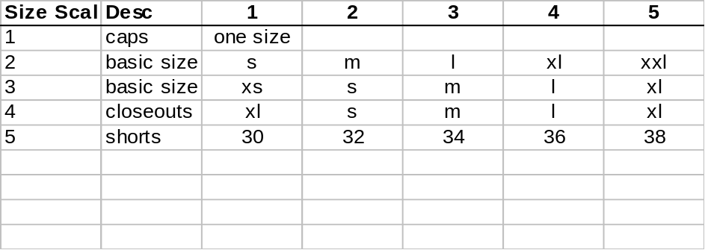

  - Warehouse file: This will read from the warehouse code sent from CampDavid and attached below with the code, description and the address information for each warehouse
    - Cwarecode = WHSECODE
    - cdesc = Whse Description
    - caddress1 = ShipToAddressLine1
    - caddress2 =
    - caddress3 = Will be only the charc before the ',' in the "ShipToAddressLine2"
    - caddress4 = 2 letters sfter the ',' in the "ShipToAddressLine2" with no spaces
    - caddress5 = The last 5 Chars in the "ShipToAddressLine2" with no spaces , if empty then it will be "ShipToAddressLine3"
    - caddress6 = ‘USA’

  - 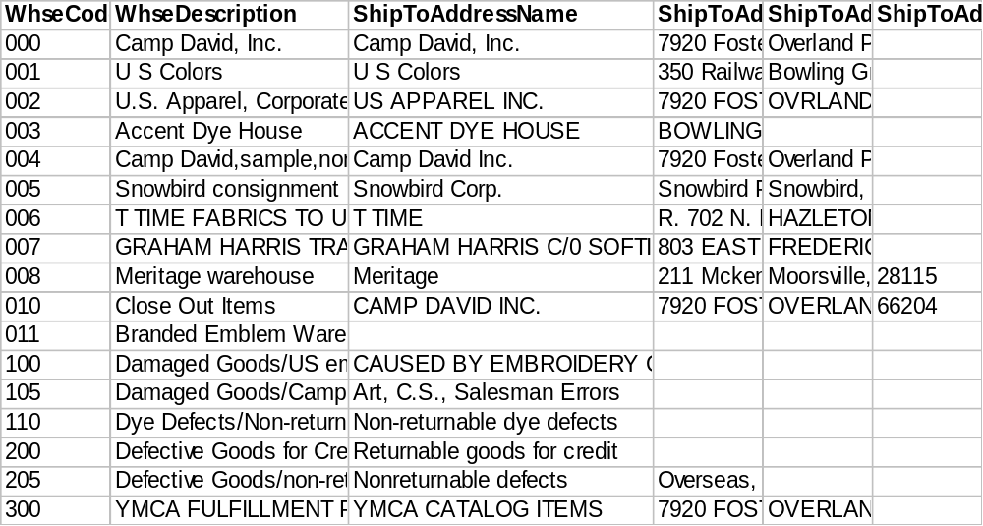
  - Style file: Will read from the Inventory Master file and the Inventory warehouse matrix file, both files will be attached as specs, also the mapping for the fields will be listed in the entity features section
Attached also a file containing the matching code for the styles that originally was bigger than 12 Chars
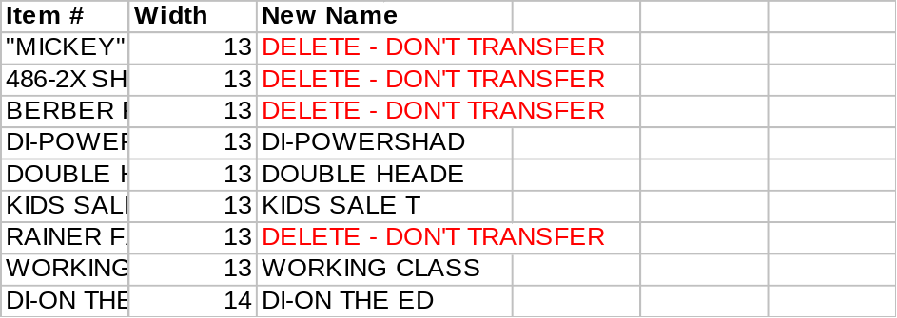
  - Stydye File : Will read from the Inventory Item warehouse file , file will be attached to the web entry as a spec, also the mapping for the fields will be listed in the entity features section
  - Codes file: This will be 2 codes ass follow
    - Color Codes: Will be from the Matrix Row label file which is attached below
        - Color code = Row Label Code
        - Color Description = Row Label Description
RowLabelCode | RowLabelDescription | RowLabelName
7025 | 50/50 Crew Neck Fleece | 50/50 CREW
7026 | 50/50 Hooded Fleece Pullover | 50/50 HOOD
<none>
AQUA | Aqua | AQUA
ASH | Ash | ASH
ASPHLT | Asphalt | ASPHALT
ATH/WH | Athletic Heather with White | ATH/WH
ATHGLD | Athletic Gold | ATHGLD
ATHHEA | Athletic Heather | ATHHEA
ATHHTH | Athletic Heather/Graphite | ATHH/GRAPH
B/G/W | Black/Gold/White | BLK/GLD/WH
BARLEY | Barley | BARLEY
BARN | Barn Red | BARN
BASIL | Basil | BASIL
BERRY | Berry | BERRY
BISCUI | Biscuit | BISCUIT
BL/GLD | Black/Gold | Black/Gold
BLACAM | Black/Camel | BLACAM
BLACK | Black | BLACK
BLACRE | Black/Cream | BLACRE
BLARED | Black/Red | BLARED
BLATOB | Black/Tobacco | BLATOB
BLAWHI | Black/White | BLAWHI
BLK/CH | Black/Chino | BLK/CHINO
BLK/GO | Black wtih gold stitching | Black/gold
BLK/RE | Black with red stitching | Black/red
BLK/RO | Black with royal stitching | Black/roya
BLK/ST | Black/Stone | BLK/STONE
BLUE | Blue | BLUE
BLUEBE | Blueberry | BLUEBE
BLUEGR | Bluegrass | BLUEGR
BLUHTR | Blue Heather | BLUE HTR
BLUSPR | Blue Spruce | BLUSPR
BRICK | Brick | BRICK
BRNHEA | Brown Heather | Brown Hea
BROWN | Brown | BROWN
BURGAN | Burgandy | BURGAN
BUTTER | Buttercup | BUTTERCUP
CACTUS | Cactus | CACTUS
CAPBLA | Cappucino/Black | CappucBlac
CAPPUC | Cappucino | CAPPUC
CARBLU | Carolina Blue | CARBLU
CARDIN | Cardinal | CARDIN
CARMEL | Carmel | CARMEL
CAYMAN | Cayman | CAYMAN
CEDAR | Cedar | CEDAR
CELERY | Celery | CELERY
CEMENT | Cement | CEMENT
CEMMOS | Cement/Moss | CEMMOS
CEMNAV | Cement/Moss | CEMNAV
CEMSAG | Cement/Sage | CEMSAG
CEMSTO | Cement/Storm | CEMSTO
CH/BLK | Chino/Black | CHINO/BLK
CH/RUB | Charcoal/Ruby | CHAR/RUBY
CHACRE | Charcoal/Cream | CHACRE
CHAMBR | Chambray | CHAMBR
CHAMOI | Chamois | CHAMOI
CHARCO | Charcoal | CHARCO
CHESTN | Chestnut | CHESTN
CHINO | Chino | CHINO
CHN/NV | Chino/Navy | CHINO/NVY
CHOC | Chocolate | CHOCOLATE
CHR/BL | Charcoal/Black | CHAR/BLK
CITRUS | Citrus | CITRUS
COPPER | Copper | COPPER
CORAL | Coral | CORAL
CORN/N | Cornsilk/Navy | Cornsilk/N
CORNSI | Cornsilk | CORNSI
COSMO | Cosmo Pink | COSMO PINK
CRANBE | Cranberry | CRANBE
CREAM | Cream | CREAM
CRIMSO | Crimson | CRIMSO
DAFFOD | Daffodil | DAFFOD
DAISY | Daisy | DAISY
DARKBL | Dark Blue | DARKBL
DAROLI | Dark Olive | DAROLI
DENIM | Denim | DENIM
DK NVY | Dark Navy | DK NVY
DKGRAV | Dark Gravel | DRK GRAVEL
DOVE | Dove | DOVE
DOVER | DOVER GRAY | DOVER
DUSLEM | DUSTY LEMON | DUSLEM
DUSLIM | DUSTY LIME | DUSLIM
DUSPEA | DUSTY PEACH | DUSPEA
EGGPLA | Egg Plant | EGGPLA
EMERLD | Emerald | EMERLD
EUCALY | Eucalyptus | EUCALY
EVRGRN | Evergreen | Evergreen
FOREST | Forest | FOREST
FOSSIL | Khaki for Polynosics | FOSSIL
FUSHIA | FUSCHIA | FUSHIA
G/KH/G | Green/Khaki/Gold | GR/KHA/GLD
GARNET | Garnet | GARNET
GOL/NV | Gold/Navy | GOLD/NAVY
GOLD | Gold | GOLD
GOLDN | Golden | GOLDEN
GRA/NV | Gray/Navy | GRA/NV
GRAHEA | Gray Heather | GRAHEA
GRANIT | Granite | GRANIT
GRAPE | Purple. | GRAPE
GRAPH | Graphite | GRAPH
GRAPHI | Graphite Heather | GRAPHHTHR
GRAVEL | Gravel | GRAVEL
GRAY | Gray | GRAY
GREEN | Green | GREEN
GRV/NV | Gravel/Navy | GRV/NV
GRY/NV | Grey/Navy | Grey/Navy
GRY/RD | Grey/Red | Grey/Red
GRY/WE | Athletic heather/wedgewood | GRY/WE
GRYFOR | Grey heather body/forest slvs | GRYFOR
GUNPOW | Gunpowder | GUNPOW
HARBOR | Harbor Blue | HARBOR
HOR/CH | Horizon/Chino | HORIZ/CHIN
HOR/NV | Horizon/Navy | HORZN/NAVY
HORIZO | Horizon | HORIZO
HUNTER | Green | HUNTER
INDIGO | Indigo | INDIGO
IRIS | Iris | IRIS
IVY | Ivy | IVY
JADE | Jade | JADE
K/B/R | Khaki/ Black/Red | KH/BLK/RD
KELLY | Kelly Green | KELLY
KH/N/W | Khaki/Navy/White | KH/NV/WH
KHA/BL | Khaki/Black | KHA/BL
KHACRE | Khaki/Cream | KHACRE
KHADEN | Khaki/Denim | KHADEN
KHAFOR | Khaki/Forest | KHAFOR
KHAKI | Khaki | KHAKI
KHAMOS | Khaki/Moss | KHAMOS
KHATAN | Khaki/Tan | KHATAN
KHK/NV | Khaki/Navy | KHAKI/NVY
KIWI | Kiwi | KIWI
LAGOON | Lagoon | LAGOON
LAKE | Lake | LAKE
LAVEND | Lavender | LAVENDER
LBL/WH | Light blue with White | LBL/WH
LEMON | Lemon | LEMON
LIBERT | navy | LIBERT
LILAC | Lilac | LILAC
LIME | Lime | LIME
LODEN | Loden | LODEN
LT.BLU | Light Blue | LT.BLU
MANG0 | Mango | MANG0
MANGO | Mango | MANGO
MAROON | Maroon | MAROON
MOSS | Moss | MOSS
MU/OX | Gold/Oxford | GOLD/OX
MUS/NV | Mustard/Navy | MUST/NVY
MUSHRM | Mushroom | MUSHRM
MUSNVY | Mustard/Navy | MUSNVY
MUSTAR | Mustard | MUSTAR
N/G/W | Navy/Gold/White | NV/GLD/WHT
N/R/W | Navy/Red/White | NVY/RD/WH
N/S/K | Navy/Stone/Khaki | NV/STN/KH
NATURA | Natural | NATURA
NAV/GR | Navy/Lt.Grey Stitch | NAV/LT.GRY
NAVKHA | Navy/Khaki | NAVKHA
NAVMOS | Navy/Moss | NAVMOS
NAVNAT | Navy/Natural | NAVNAT
NAVSAG | Navy/Sage | NAVSAG
NAVY | Navy | NAVY
NUTMEG | Nutmeg | NUTMEG
NV/GLD | Navy/Gold | NAVY/GOLD
NV/HTR | Navy / Heather | NVY/HTR
NV/OXF | Navy/Oxford | NV/OXF
NVY/CH | Navy/Chino | NAVY/CH
NVY/GR | Navy/Grey | NVY/GR
NVY/MU | Navy / Mustard | NAVY/MUSTA
NVY/OX | Navy/ Oxford Trim | NVY/OX
NVY/ST | Navy/Stone | NVY/STONE
NVY/WH | Navy with white | NVY/WH
NVYCEM | Navy/Cement | NVYCEM
NVYNVY | Navy heather/ Navy | NVY/NAVY
O/NV/W | Orange/Navy/White | OR/NVY/WHT
OAT/BR | Oatmeal Heather/Brown Heather | OAT/BROWN
OATBRN | Oatmeal heather/ Brown heather | OAT/BROWN
OATMEA | Oatmeal | OATMEA
OCEAN | Ocean | OCEAN
OLDGOL | Old Gold | OLD GOLD
OLIVE | Olive | OLIVE
ORANGE | Orange | ORANGE
ORG/NV | Orange/Navy | ORG/NV
ORG/OX | Orange/ Oxford trim | ORG/OX
OX/CHA | oxford/charcoal | OX/CHAR
OX/RUB | char/ruby | CHAR/RUBY
OXEVER | Oxford heather / Evergreen hea | OX/EVERGRE
OXF/MU | Oxford/Mustard | OXF/MU
OXF/NV | Oxford/Navy | OXF/NV
OXFORD | Oxford Grey | OXFORD
P/G/W | Purple/Gold/White | PUR/GLD/WH
PAC/SP | Pacific/Spearmint | PAC/SP
PACIFI | Pacific | PACIFI
PALM | Palm | PALM
PALROS | Pale Rose | PALROS
PEACH | Peach | PEACH
PEARL | Pearl Grey | PEARL
PEBBLE | Pebble | PEBBLE
PERSIA | Persian (Heather Grey) | PERSIA
PEWTER | Pewter | PEWTER
PFD | PREPARED FOR DYE | PFD
PINA C | Pina Colada | PINA C
PINE | Pine | PINE
PINEAP | Pineapple | PINEAP
PINK | Pink | PINK
PLUM | Plum | PLUM
POPPNK | Pop Pink | POP PINK
PORT | Port,plum | PORT
POSTBL | Postal Blue | POSTALBLUE
PRADST | Prairie Dust | PRAIR DUST
PRIM | Primrose | PRIMROSE
PUR/GR | Purple/Gray | PURP/GRAY
PURPLE | Purple | PURPLE
PUTKHA | PUTTY / KHAKI, VERTICAL CHECL | PUTKHA
PUTTY | Putty | PUTTY
R/BL/W | Red/Black/White | RED/BLK/WH
RBY/CH | Ruby/Chino | RUBY/CHINO
RD/BLK | Red/Black | RED/BLACK
RD/KHA | Red/Khaki | RD/KHA
RED | Red | RED
RED/BL | Red/Black | RED/BLK
RED/WH | Red / White | RED/WHITE
REDNAV | Red/Navy | REDNAV
REPUBL | Republic | REPUBL
RO/BLK | Royal/Blk | ROYAL/BLK
ROYAL | Royal Blue | ROYAL
RS RED | Rockstar Red | RCKSTR RED
RUB/OX | Ruby/Oxford trim | RUB/OX
RUBNAV | Ruby/Navy | RUBNAV
RUBY | Ruby | RUBY
S/B/W | Stone/Black/White | STN/BLK/WH
SAFFRO | Saffron | SAFFRO
SAG/KH | Sage/Khaki | SAGE/KHAKI
SAGE | Sage | SAGE
SAGNAV | Sage/Navy | SAGNAV
SAND | Sand | SAND
SAPPHR | Sapphire | SAPPHR
SCANAV | Scarlet/Navy | SCANAV
SCARLE | Scarlet | SCARLE
SEA/NV | Seagrass/Navy | Sea/Nv
SEAFM | Seafoam | SEAFOAM
SEAGRA | Seagrass | SEAGRA
SEAMST | Seamist | SEAMST
SESAME | Sesame | SESAME
SHALE | Shale | SHALE
SILVER | Silver | SILVER
SKY | Sky | SKY
SKYBLU | Sky Blue | SKYBLU
SMOKE | Smoke | SMOKE
SOLEIL | Soleil | SOLEIL
SPEARM | Spearmint | SPEARM
SPRUCE | Spruce | SPRUCE
SPTGRY | Sport Grey | SPORT GREY
ST/BLK | Stone/Black | STONE/BLK
STEEL | Steel | Steel
STEWHT | Steel / White | Steel/Whit
STLDOV | STEEL/DOVE | STEEL/DOVE
STOFOR | Stone/Forest | STOFOR
STOMOS | Stone/Moss | STOMOS
STONAV | Stone/Navy | STONAV
STONE | Stone | STONE
STORM | Storm | STORM
STRAW | Straw | STRAW
SUN/PC | Sundance/Pacific | SUN/PC
SUNDAN | Sundance | SUNDAN
SUNFLO | Sunflower | SUNFLO
TAN | Tan | TAN
TANGEL | Tangelo | TANGEL
TAUPE | Taupe | TAUPE
TAUPUT | Taupe/Putty | TAUPUT
TEAL | Teal | TEAL
TENN | Tennesse Orange | TENN
TOBACC | Tobacco | TOBACC
TROPIC | Tropicana | TROPICANA
TRTEAL | Tropic Teal | TROP TEAL
TRURED | True Red | TRUE RED
TURQ | Turquoise | TURQ
VANILL | Vanila | VANILL
VINBLU | Vintage Blue | VINT.BLUE
WATERM | Watermelon | WATERM
WEDGWO | Wedgewood | WEDGWO
WH/MAR | White/Maroon | WHT/MAROON
WH/PUR | White/Purple | WHT/PURPLE
WH/RED | White/Red | WHT/RED
WHEAT | Wheat | WHEAT
WHIDKG | WHITE/DARK GREEN | WHIDKG
WHIRED | White/Red | WHIRED
WHITE | White | WHITE
WHT/AT | White/Athletic Heather | WHT/ATHHTR
WHT/BB | White with Blueberry trim | WHT/BB
WHT/BL | White/Black Ringer | WHT/BL
WHT/GR | White/Heather Gray | WHT/GR
WHT/LT | White/Lt.Blue | WHT/LT.BLU
WHT/MA | White/Mango | WHT/MA
WHT/NV | White/Navy | WHT/NAVY
WHT/PI | White/Pineapple Trim | WHT/PI
WHT/PL | White/Plum Trim | WHT/PL
WHT/RU | White/Ruby | WHT/RUBY
WHT/SA | White/Sage | WHT/SA
WHT/SE | White/Seamist | WHT/SE
WHT/ST | White/Storm | WHT/ST
WHT/WA | White/Watermelon Trim | WHT/WA
WHT/WE | White/Wedgewood | WHT/WE
WHTFOR | White body w/ forest grn slevs | WHTFOR
WILLOW | Willow | WILLOW
WINE | Wine | WINE
YELLO |  | Honeycomb
YELLOW | Yellow | YELLOW

    - Style group code: Will read from the Product line size scale and the data sent is attached below
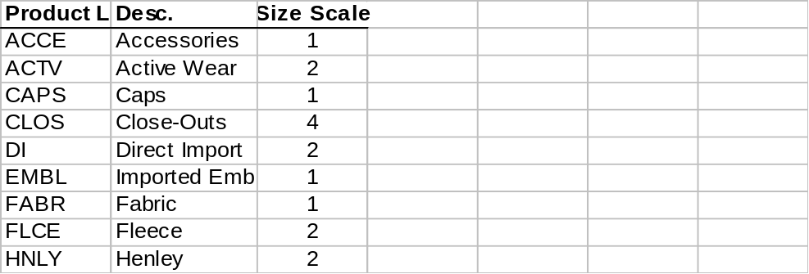

Entity Features

List of the fields mapped between the old and new files
Aria File | Aria field | CampDavid File | CampDavid Field
Style | Style Major | Inventory Master file | Item Number
Style | Short Desc | Inventory Master file | ItemDescription
Style | Long Desc | Inventory Master file | ItemDescription+color description
Style | Quality | Inventory Master file | All the styles will be converted as first quality
Style | Def Location | Inventory Master file | DefaultWhse
Style | Group | Inventory Master file | PROD LINE (This is one of the codes to be converted and mentioned above in this document)
Style | Discount | Inventory Master file | TradeDiscount
Style | Price Level A | Inventory Master file | StdPrice
Style | Retail Price | Inventory Master file | SuggestedRetailPrice
Style | Inventory Style | Inventory Master file | SALES HIST/ RECPT HIST
Style | Detail Costing | Inventory Master file | Will be ‘Y’ for all the styles at the time of conversion
Style | Avg_cost | Inventory Master file | AVERAGE COST
Style | Style | Inventory Item Warehouse Matrix | This field will be a combination from of:  Item number+ spacec(if item number is less than 12 chars) +’-‘ Row label code which is the color code in Aria
Style | Scale | Inventory Item Warehouse Matrix | The scale code itself will be defined from the matrix of the Product – line scale attached
Style | Vendor | Inventory Item Vendor | VendorNumber
Style | Supplier # | Inventory Item Vendor | VendorAliasPartNumber
Style | Lead time | Inventory Item Vendor | LastLeadTime
StyDye | Style | Inventory Item Warehouse Matrix | This field will be a combination from of:  Item number+ spacec(if item number is less than 12 chars) +’-‘ Row label code which is the color code in Aria
StyDye | cwarecode | Inventory Item Warehouse Matrix | WhseCode

User Interface (UI)
[Show the system UI modifications here, if any. Otherwise omit this section. This if used must include screens/reports prototypes.]

Option Grid
# | Item | Operator | Value

Use Cases
Scenario | Step # | Description | # | User Actions | System Action
 | 1 |  | 1
 |  |  | 2
 |  |  | 3
 | 2 |  | 1
 |  |  | 2
 |  |  | 3

UI Rules
Ser. | Screen Object | Attribute | Value
1 |  | Description
 |  | Control Type
 |  | Source
 |  | Caption
 |  | Visible | [default is True]
 |  | Enabled | [default is True]
 |  | Mandatory | [default is False]
 |  | Tab Sequence
 |  | Default Value
 |  | List of Values (LOV) | [usually by having a list button that calls a lookup file]
 |  | Validations
 |  | Post-Object Processing | [Actions to be done with a certain event (button pressed, field exited, list option selected…etc)]
 |  | … | [Add any additional attributes you need]
2

Option Grid Rules
Ser. | Grid Item | Attribute | Value
1 |  | Description
 |  | Control Type
 |  | Default Value
 |  | Action
 |  | Source
 |  | Browse fields
 |  | Validations
 |  | Suppress condition
2

Application Tier
- Class Description

- Class Responsibilities

- Relationships with Other Classes:

Related Class | Based on | Depends on | Uses
- Special Requirements

- Class Interface (Properties/Controls/Methods/Events)
Properties:
# | Name | Description | Data Type
Class Controls:
# | Control Name | Description | Init Properties
Methods:
# | Name |  |  | Description
1
 | Method Signature
 | Parameters |  |  |  |  |  | Return
 | # | Name | Description |  | Opt | Default | Value | Condition
2
 | Method Signature
 | Parameters |  |  |  |  |  | Return
 | # | Name | Description |  | Opt | Default | Value | Condition
Events:
# | Control Name | Control Event | Action

Database Design
[Describe the system database modifications here, if any. Otherwise omit this section.]

Testing Cases
Test Setup:

# | Test Settings
1
2

Test Cases:

Test | Repeat by Setting | Test Actions | Test Results | OK

